Supplements.
Content.
eFigure1. Multimodal retinal imaging in patients from family F178………………………p.2
eFigure2. Ultrasound biomicroscopy in patient CIC12548.………………………………..p.3
eTable1. The molecular diagnosis NGS panel including 164 genes associated with pediatric inherited retinal diseases……………………………………………………………………p.4
eTable2. Homozygous variants found in ES for autosomal recessive model……………....p.11
Discussion of VSX2 variants identified herein in respect to the literature………………... p.11
References…………………………………………………………………………………..p.12

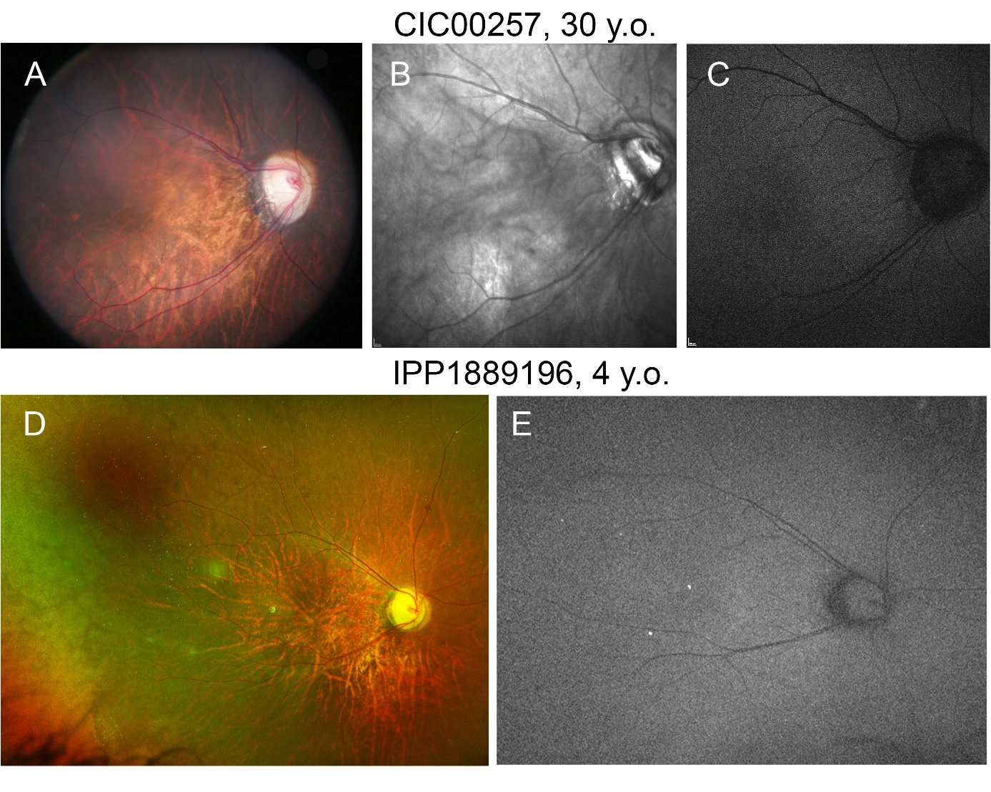
eFigure 1. Multimodal retinal imaging in patients from family F178. Top, patient CIC00257. A, fundus photo. Myopic fundus abnormalities with oval tilted optic discs, temporal pallor and peripapillary chorio-retinal atrophy, narrowed retinal vessels and thinned retina with increased choroidal visibility. B, Infrared reflectance. No obvious changes in retinal reflectance besides increased choroidal visibility. C, Short-wavelength fundus autofluorescence. No obvious changes. Bottom, patient IPP1889196. D, wide-field fundus photo. Myopic fundus abnormalities with oval titled optic disc, temporal pallor, narrowed retinal vessels, retinal thinning. White-without-pressure in temporal periphery. E, wide-field short-wavelength fundus autofluorescence. No obvious changes.

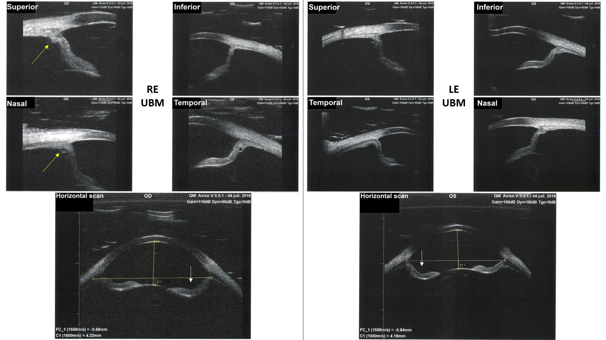
eFigure 2. Ultrasound biomicroscopy in CIC12548. Hypoplastic ciliary body (yellow arrows). Posterior iris bowing (white arrows).

eTable 1. The molecular diagnosis NGS panel including 164 genes associated with pediatric inherited retinal diseases.
Name | Transcript | Chr | Start(hg19) | End(hg19) | Refseq | Description
ABCA4 | ENST00000370225_1 | 1 | 94458393 | 94586688 | NM_000350 | ATP-binding cassette, sub-family A (ABC1), member 4
ACBD5 | ENST00000396271_10 | 10 | 27484146 | 27529744 | NM_145698 | acyl-CoA binding domain containing 5
ADAM9 | ENST00000487273_8 | 8 | 38854505 | 38962520 | NM_003816 | ADAM metallopeptidase domain 9
AHI1 | ENST00000327035_6 | 6 | 135708922 | 135818883 | NM_001134832 | Abelson helper integration site 1
 | ENST00000457866_6 | 6 | 135605124 | 135818903 | NM_017651 | Abelson helper integration site 1
AIPL1 | ENST00000381129_17 | 17 | 6327057 | 6338505 | NM_014336 | aryl hydrocarbon receptor interacting protein-like 1
ALMS1 | ENST00000264448_2 | 2 | 73612886 | 73837046 | XM_005264552 | Alstrom syndrome 1
ARL13B | ENST00000471138_3 | 3 | 93698999 | 93772913 | NM_182896 | ADP-ribosylation factor-like 13B
ARL2BP | ENST00000219204_16 | 16 | 57279010 | 57287516 | NM_012106 | ADP-ribosylation factor-like 2 binding protein
ARL6 | ENST00000493990_3 | 3 | 97483365 | 97519953 |  | ADP-ribosylation factor-like 6
ATF6 | ENST00000367942_1 | 1 | 161736084 | 161933860 | NM_007348 | activating transcription factor 6
ATXN7 | ENST00000484332_3 | 3 | 63953420 | 63985472 | NM_001128149 | ataxin 7
 | ENST00000538065_3 | 3 | 63898275 | 63989129 |  | ataxin 7
C1QTNF5 | ENST00000528368_11 | 11 | 119209652 | 119211593 | NM_001278431 | C1q and tumor necrosis factor related protein 5
C21orf2 | ENST00000397956_21 | 21 | 45749774 | 45759276 | NM_001271441 | chromosome 21 open reading frame 2
C2orf71 | ENST00000331664_2 | 2 | 29284558 | 29297127 | NM_001029883 | chromosome 2 open reading frame 71
C5orf42 | ENST00000425232_5 | 5 | 37106330 | 37249530 | XM_005248352 | chromosome 5 open reading frame 42
C8orf37 | ENST00000286688_8 | 8 | 96257147 | 96281429 | NM_177965 | chromosome 8 open reading frame 37
CA4 | ENST00000300900_17 | 17 | 58227297 | 58236901 | NM_000717 | carbonic anhydrase IV
CABP4 | ENST00000438189_11 | 11 | 67219886 | 67226699 | XM_005274116 | calcium binding protein 4
 | ENST00000325656_11 | 11 | 67222818 | 67226524 | XM_005274114 | calcium binding protein 4
CACNA1F | ENST00000376265_X | X | 49061523 | 49089833 | NM_005183 | calcium channel, voltage-dependent, L type, alpha 1F subunit
 | ENST00000376251_X | X | 49061523 | 49089771 | NM_001256790 | calcium channel, voltage-dependent, L type, alpha 1F subunit
CACNA2D4 | ENST00000382722_12 | 12 | 1901123 | 2028002 | NM_172364 | calcium channel, voltage-dependent, alpha 2/delta subunit 4
CC2D2A | ENST00000503658_4 | 4 | 15471637 | 15483000 |  | coiled-coil and C2 domain containing 2A
 | ENST00000515124_4 | 4 | 15471536 | 15483883 | NM_001164720 | coiled-coil and C2 domain containing 2A
 | ENST00000413206_4 | 4 | 15471489 | 15603180 | XM_005248179 | coiled-coil and C2 domain containing 2A
CCT2 | ENST00000299300_12 | 12 | 69979114 | 69995350 | XM_005268574 | chaperonin containing TCP1, subunit 2 (beta)
CDH3 | ENST00000264012_16 | 16 | 68678739 | 68732971 | NM_001793 | cadherin 3, type 1, P-cadherin (placental)
CDHR1 | ENST00000332904_10 | 10 | 85954410 | 85979377 | NM_001171971 | cadherin-related family member 1
 | ENST00000372117_10 | 10 | 85954414 | 85977122 | NM_033100 | cadherin-related family member 1
CEP104 | ENST00000378230_1 | 1 | 3728645 | 3773763 | XM_005244815 | centrosomal protein 104kDa
CEP164 | ENST00000278935_11 | 11 | 117198571 | 117283984 | XM_005271460 | centrosomal protein 164kDa
CEP290 | ENST00000552810_12 | 12 | 88442797 | 88535993 | XM_005269161 | centrosomal protein 290kDa
CEP41 | ENST00000489512_7 | 7 | 130058875 | 130080897 | NM_001257160 | centrosomal protein 41kDa
 | ENST00000223208_7 | 7 | 130033612 | 130081078 | XM_005277633 | centrosomal protein 41kDa
CERKL | ENST00000339098_2 | 2 | 182402911 | 182521733 |  | ceramide kinase-like
CLN3 | ENST00000359984_16 | 16 | 28488600 | 28503403 | NM_000086 | ceroid-lipofuscinosis, neuronal 3
CLRN1 | ENST00000328863_3 | 3 | 150645723 | 150690495 | NM_001195794 | clarin 1
 | ENST00000295911_3 | 3 | 150643950 | 150662023 | NM_052995 | clarin 1
CLUAP1 | ENST00000576634_16 | 16 | 3550924 | 3589048 | NM_015041 | clusterin associated protein 1
CNGA1 | ENST00000402813_4 | 4 | 47937994 | 47983552 | XM_005248050 | cyclic nucleotide gated channel alpha 1
CNGA3 | ENST00000393504_2 | 2 | 98962618 | 99015057 | NM_001298 | cyclic nucleotide gated channel alpha 3
CNGB1 | ENST00000311183_16 | 16 | 57988579 | 58005020 | NM_001135639 | cyclic nucleotide gated channel beta 1
 | ENST00000251102_16 | 16 | 57917706 | 58005016 | NM_001297 | cyclic nucleotide gated channel beta 1
CNGB3 | ENST00000320005_8 | 8 | 87586163 | 87755903 | NM_019098 | cyclic nucleotide gated channel beta 3
CNNM4 | ENST00000377075_2 | 2 | 97426639 | 97477628 | NM_020184 | cyclin M4
COL18A1 | ENST00000400337_21 | 21 | 46825052 | 46933634 | XM_005261181 | collagen, type XVIII, alpha 1
 | ENST00000355480_21 | 21 | 46875403 | 46933634 | XM_005261178 | collagen, type XVIII, alpha 1
 | ENST00000359759_21 | 21 | 46875424 | 46933633 | XM_005261182 | collagen, type XVIII, alpha 1
CRB1 | ENST00000535699_1 | 1 | 197170592 | 197447212 | NM_001257965 | crumbs homolog 1 (Drosophila)
 | ENST00000367400_1 | 1 | 197237408 | 197447585 | NM_201253 | crumbs homolog 1 (Drosophila)
CRX | ENST00000221996_19 | 19 | 48325097 | 48346587 | NM_000554 | cone-rod homeobox
CSPP1 | ENST00000262210_8 | 8 | 67976603 | 68108498 | XM_005251311 | centrosome and spindle pole associated protein 1
CYP4V2 | ENST00000378802_4 | 4 | 187112674 | 187131955 | XM_005262935 | cytochrome P450, family 4, subfamily V, polypeptide 2
DHDDS | ENST00000360009_1 | 1 | 26758846 | 26797785 | NM_024887 | dehydrodolichyl diphosphate synthase
DHX38 | ENST00000268482_16 | 16 | 72127461 | 72146811 | XM_005256268 | DEAH (Asp-Glu-Ala-His) box polypeptide 38
DRAM2 | ENST00000539140_1 | 1 | 111659957 | 111682838 | NM_178454 | DNA-damage regulated autophagy modulator 2
EFEMP1 | ENST00000394555_2 | 2 | 56093102 | 56151274 | NM_001039348 | EGF containing fibulin-like extracellular matrix protein 1
ELOVL4 | ENST00000369816_6 | 6 | 80624529 | 80657297 | NM_022726 | ELOVL fatty acid elongase 4
EYS | ENST00000370621_6 | 6 | 64430032 | 66417107 |  | eyes shut homolog (Drosophila)
 | ENST00000393380_6 | 6 | 66039165 | 66417118 | NM_001142801 | eyes shut homolog (Drosophila)
FAM161A | ENST00000404929_2 | 2 | 62051991 | 62081188 | NM_001201543 | family with sequence similarity 161, member A
FLVCR1 | ENST00000366971_1 | 1 | 213031597 | 213072705 | NM_014053 | feline leukemia virus subgroup C cellular receptor 1
FSCN2 | ENST00000334850_17 | 17 | 79495558 | 79504106 | XM_005257195 | fascin homolog 2, actin-bundling protein, retinal (Strongylocentrotus purpuratus)
GNAT1 | ENST00000232461_3 | 3 | 50229045 | 50233949 | NM_144499 | guanine nucleotide binding protein, alpha transducing activity polypeptide 1
GNAT2 | ENST00000351050_1 | 1 | 110145889 | 110155679 | NM_005272 | guanine nucleotide binding protein , alpha transducing activity polypeptide 2
GNPTG | ENST00000204679_16 | 16 | 1401924 | 1413352 | NM_032520 | N-acetylglucosamine-1-phosphate transferase, gamma subunit
GPR125 | ENST00000334304_4 | 4 | 22389007 | 22517677 | XM_005248137 | G protein-coupled receptor 125
GPR179 | ENST00000342292_17 | 17 | 36481493 | 36499693 | NM_001004334 | G protein-coupled receptor 179
GRM6 | ENST00000231188_5 | 5 | 178405328 | 178422124 | NM_000843 | glutamate receptor, metabotropic 6
GUCA1A | ENST00000053469_6 | 6 | 42123174 | 42147794 | XM_005249037 | guanylate cyclase activator 1A (retina)
GUCA1B | ENST00000230361_6 | 6 | 42152139 | 42162654 | NM_002098 | guanylate cyclase activator 1B (retina)
GUCY2D | ENST00000254854_17 | 17 | 7905912 | 7923657 | NM_000180 | guanylate cyclase 2D, membrane (retina-specific)
HGSNAT | ENST00000379644_8 | 8 | 42995598 | 43057998 | XM_005273692 | heparan-alpha-glucosaminide N-acetyltransferase
HK1 | ENST00000404387_10 | 10 | 71048500 | 71160891 | XM_005269736 | hexokinase 1
 | ENST00000359426_10 | 10 | 71078600 | 71161638 | XM_005269737 | hexokinase 1
 | ENST00000360289_10 | 10 | 71029756 | 71161635 | NM_033498 | hexokinase 1
 | ENST00000298649_10 | 10 | 71075610 | 71161635 | NM_033496 | hexokinase 1
IDH3B | ENST00000380851_20 | 20 | 2639041 | 2644865 | NM_001258384 | isocitrate dehydrogenase 3 (NAD+) beta
 | ENST00000380843_20 | 20 | 2639041 | 2644865 | XM_005260716 | isocitrate dehydrogenase 3 (NAD+) beta
IFT140 | ENST00000426508_16 | 16 | 1560428 | 1662111 | XM_005255724 | intraflagellar transport 140 homolog (Chlamydomonas)
IFT172 | ENST00000260570_2 | 2 | 27667238 | 27712624 | NM_015662 | intraflagellar transport 172 homolog (Chlamydomonas)
IMPDH1 | ENST00000338791_7 | 7 | 128032331 | 128050306 | XM_005250315 | IMP (inosine 5'-monophosphate) dehydrogenase 1
 | ENST00000354269_7 | 7 | 128032332 | 128050036 | XM_005250315 | IMP (inosine 5'-monophosphate) dehydrogenase 1
IMPG1 | ENST00000369950_6 | 6 | 76630832 | 76782395 | NM_001563 | interphotoreceptor matrix proteoglycan 1
IMPG2 | ENST00000193391_3 | 3 | 100941390 | 101039404 | NM_016247 | interphotoreceptor matrix proteoglycan 2
INPP5E | ENST00000371712_9 | 9 | 139323071 | 139334274 | XM_005266094 | inositol polyphosphate-5-phosphatase, 72 kDa
INVS | ENST00000262457_9 | 9 | 102861538 | 103063282 | NM_014425 | inversin
IQCB1 | ENST00000310864_3 | 3 | 121488610 | 121553926 | XM_005247913 | IQ motif containing B1
ITM2B | ENST00000378565_13 | 13 | 48807294 | 48836460 | NM_021999 | integral membrane protein 2B
KCNJ13 | ENST00000233826_2 | 2 | 233631174 | 233641278 | NM_002242 | potassium inwardly-rectifying channel, subfamily J, member 13
KCNV2 | ENST00000382082_9 | 9 | 2717502 | 2730037 | NM_133497 | potassium channel, subfamily V, member 2
KIAA1549 | ENST00000422774_7 | 7 | 138522270 | 138666064 |  | KIAA1549
KIF7 | ENST00000394412_15 | 15 | 90171208 | 90198682 | XM_005254904 | kinesin family member 7
KIZ | ENST00000619189_20 | 20 | 21106695 | 21227260 | XM_011529298 | kizuna centrosomal protein
KLHL7 | ENST00000322275_7 | 7 | 23145404 | 23165664 | NM_001172428 | kelch-like family member 7
 | ENST00000339077_7 | 7 | 23145403 | 23217533 | NM_001031710 | kelch-like family member 7
LAMA1 | ENST00000389658_18 | 18 | 6941743 | 7117813 | NM_005559 | laminin, alpha 1
LRAT | ENST00000336356_4 | 4 | 155665123 | 155674270 | NM_004744 | lecithin retinol acyltransferase (phosphatidylcholine--retinol O-acyltransferase)
LRIT3 | ENST00000594814_4 | 4 | 110769358 | 110793471 | NM_198506 | leucine-rich repeat, immunoglobulin-like and transmembrane domains 3
MAK | ENST00000474039_6 | 6 | 10762956 | 10838764 | XM_005249114 | male germ cell-associated kinase
MERTK | ENST00000295408_2 | 2 | 112656056 | 112787138 | XM_005263568 | c-mer proto-oncogene tyrosine kinase
NEK2 | ENST00000366998_1 | 1 | 211839772 | 211848899 | NM_001204183 | NIMA-related kinase 2
 | ENST00000366999_1 | 1 | 211836114 | 211848960 | NM_002497 | NIMA-related kinase 2
NEUROD1 | ENST00000295108_2 | 2 | 182541194 | 182545603 | NM_002500 | neuronal differentiation 1
NMNAT1 | ENST00000377205_1 | 1 | 10003486 | 10045556 | NM_022787 | nicotinamide nucleotide adenylyltransferase 1
 | ENST00000403197_1 | 1 | 10003486 | 10041824 | XM_005263489 | nicotinamide nucleotide adenylyltransferase 1
NPHP1 | ENST00000316534_2 | 2 | 110879888 | 110962619 |  | nephronophthisis 1 (juvenile)
NPHP3 | ENST00000337331_3 | 3 | 132400472 | 132441286 | NM_153240 | nephronophthisis 3 (adolescent)
NPHP4 | ENST00000378156_1 | 1 | 5922878 | 6052531 | XM_005263447 | nephronophthisis 4
NR2E3 | ENST00000621098_15 | 15 | 72102932 | 72107270 | NM_016346 | nuclear receptor subfamily 2 group E member 3
NRL | ENST00000397002_14 | 14 | 24549316 | 24553834 | XM_005267709 | neural retina leucine zipper
NYX | ENST00000342595_X | X | 41306687 | 41334963 | NM_022567 | nyctalopin
OFD1 | ENST00000340096_X | X | 13752864 | 13787472 | XM_005274601 | oral-facial-digital syndrome 1
OPN1LW | ENST00000369951_X | X | 153409698 | 153424507 | NM_020061 | opsin 1 (cone pigments), long-wave-sensitive
OPN1MW | ENST00000369935_X | X | 153448107 | 153461633 | NM_000513 | opsin 1 (cone pigments), medium-wave-sensitive
OPN1SW | ENST00000249389_7 | 7 | 128412545 | 128415844 | NM_001708 | opsin 1 (cone pigments), short-wave-sensitive
OR2W3 | ENST00000537741_1 | 1 | 248031277 | 248060449 |  | olfactory receptor, family 2, subfamily W, member 3
OTX2 | ENST00000339475_14 | 14 | 57267425 | 57277187 | NM_001270524 | orthodenticle homeobox 2
PAX2 | ENST00000428433_10 | 10 | 102505468 | 102589698 | XM_005269873 | paired box 2
 | ENST00000361791_10 | 10 | 102505468 | 102589074 | NM_003988 | paired box 2
PCYT1A | ENST00000292823_3 | 3 | 195961239 | 196014584 | XM_005269343 | phosphate cytidylyltransferase 1, choline, alpha
PDE6A | ENST00000255266_5 | 5 | 149237519 | 149324356 | NM_000440 | phosphodiesterase 6A, cGMP-specific, rod, alpha
PDE6B | ENST00000496514_4 | 4 | 619395 | 664542 |  | phosphodiesterase 6B, cGMP-specific, rod, beta
PDE6C | ENST00000371447_10 | 10 | 95372345 | 95425767 | NM_006204 | phosphodiesterase 6C, cGMP-specific, cone, alpha prime
PDE6G | ENST00000331056_17 | 17 | 79617489 | 79623607 | NM_002602 | phosphodiesterase 6G, cGMP-specific, rod, gamma
PDE6H | ENST00000266395_12 | 12 | 15125956 | 15134799 | NM_006205 | phosphodiesterase 6H, cGMP-specific, cone, gamma
PITPNM3 | ENST00000262483_17 | 17 | 6354585 | 6459814 | NM_031220 | PITPNM family member 3
POC1B | ENST00000313546_12 | 12 | 89813495 | 89919801 | NM_172240 | POC1 centriolar protein B
PPT1 | ENST00000433473_1 | 1 | 40538379 | 40563375 | NM_000310 | palmitoyl-protein thioesterase 1
PRCD | ENST00000586148_17 | 17 | 74536172 | 74539469 |  | progressive rod-cone degeneration
PROM1 | ENST00000447510_4 | 4 | 15969849 | 16077741 | NM_006017 | prominin 1
PRPF3 | ENST00000324862_1 | 1 | 150293925 | 150325671 | NM_004698 | pre-mRNA processing factor 3
PRPF31 | ENST00000321030_19 | 19 | 54618837 | 54635140 | NM_015629 | pre-mRNA processing factor 31
PRPF4 | ENST00000374198_9 | 9 | 116037922 | 116055056 | NM_001244926 | pre-mRNA processing factor 4
PRPF6 | ENST00000266079_20 | 20 | 62612488 | 62664453 | NM_012469 | pre-mRNA processing factor 6
PRPF8 | ENST00000304992_17 | 17 | 1553923 | 1588176 | NM_006445 | pre-mRNA processing factor 8
PRPH2 | ENST00000230381_6 | 6 | 42664340 | 42690312 | NM_000322 | peripherin 2 (retinal degeneration, slow)
RAB28 | ENST00000330852_4 | 4 | 13369348 | 13485989 | NM_001017979 | RAB28, member RAS oncogene family
 | ENST00000288723_4 | 4 | 13369348 | 13485989 | NM_004249 | RAB28, member RAS oncogene family
 | ENST00000338176_4 | 4 | 13369349 | 13485989 | XM_005248217 | RAB28, member RAS oncogene family
RASSF8 | ENST00000381352_12 | 12 | 26111962 | 26232825 | XM_005253295 | Ras association (RalGDS/AF-6) domain family (N-terminal) member 8
 | ENST00000542865_12 | 12 | 26126688 | 26222418 | NM_001164747 | Ras association (RalGDS/AF-6) domain family (N-terminal) member 8
RAX2 | ENST00000555978_19 | 19 | 3769087 | 3772209 | NM_032753 | retina and anterior neural fold homeobox 2
RBP3 | ENST00000224600_10 | 10 | 48381487 | 48390991 | NM_002900 | retinol binding protein 3, interstitial
RBP4 | ENST00000371464_10 | 10 | 95351444 | 95360983 | NM_006744 | retinol binding protein 4, plasma
RD3 | ENST00000367002_1 | 1 | 211649864 | 211666259 | NM_001164688 | retinal degeneration 3
RDH11 | ENST00000381346_14 | 14 | 68143518 | 68162531 | XM_005267732 | retinol dehydrogenase 11 (all-trans/9-cis/11-cis)
RDH12 | ENST00000551171_14 | 14 | 68168603 | 68201169 | NM_152443 | retinol dehydrogenase 12 (all-trans/9-cis/11-cis)
RDH5 | ENST00000257895_12 | 12 | 56114182 | 56118489 | NM_001199771 | retinol dehydrogenase 5 (11-cis/9-cis)
RGR | ENST00000359452_10 | 10 | 86004809 | 86019716 | NM_002921 | retinal G protein coupled receptor
RHO | ENST00000296271_3 | 3 | 129247483 | 129254012 | NM_000539 | rhodopsin
RIMS1 | ENST00000521978_6 | 6 | 72596727 | 73110416 | NM_014989 | regulating synaptic membrane exocytosis 1
 | ENST00000517827_6 | 6 | 72926463 | 73110571 | NM_001168410 | regulating synaptic membrane exocytosis 1
 | ENST00000401910_6 | 6 | 72922514 | 73110607 | NM_001168407 | regulating synaptic membrane exocytosis 1
RLBP1 | ENST00000268125_15 | 15 | 89753100 | 89764982 | NM_000326 | retinaldehyde binding protein 1
ROM1 | ENST00000278833_11 | 11 | 62380213 | 62382592 | NM_000327 | retinal outer segment membrane protein 1
RP1 | ENST00000220676_8 | 8 | 55528627 | 55543394 | NM_006269 | retinitis pigmentosa 1 (autosomal dominant)
RP2 | ENST00000218340_X | X | 46696375 | 46741793 | NM_006915 | retinitis pigmentosa 2 (X-linked recessive)
RP9 | ENST00000297157_7 | 7 | 33134409 | 33149002 | NM_203288 | retinitis pigmentosa 9 (autosomal dominant)
RPE65 | ENST00000262340_1 | 1 | 68894505 | 68915642 | NM_000329 | retinal pigment epithelium-specific protein 65kDa
RPGR | ENST00000378505_X | X | 38143662 | 38186797 | NM_001034853 | retinitis pigmentosa GTPase regulator
 | ENST00000318842_X | X | 38128416 | 38186817 | NM_000328 | retinitis pigmentosa GTPase regulator
RPGRIP1 | ENST00000400017_14 | 14 | 21756136 | 21819454 | XM_005267881 | retinitis pigmentosa GTPase regulator interacting protein 1
RPGRIP1L | ENST00000379925_16 | 16 | 53634690 | 53737758 | NM_015272 | RPGRIP1-like
SAG | ENST00000409110_2 | 2 | 234216467 | 234255701 | XM_005246099 | S-antigen; retina and pineal gland (arrestin)
SDCCAG8 | ENST00000366541_1 | 1 | 243419358 | 243663394 | XM_005273016 | serologically defined colon cancer antigen 8
SEMA4A | ENST00000368285_1 | 1 | 156123318 | 156147535 | XM_005245441 | semaphorin 4A
SLC24A1 | ENST00000537259_15 | 15 | 65903743 | 65953333 |  | solute carrier family 24 (sodium/potassium/calcium exchanger), member 1
 | ENST00000261892_15 | 15 | 65914270 | 65948598 | XM_005254778 | solute carrier family 24 (sodium/potassium/calcium exchanger), member 1
SLC7A14 | ENST00000231706_3 | 3 | 170177372 | 170303863 | NM_020949 | solute carrier family 7, member 14
SNRNP200 | ENST00000323853_2 | 2 | 96940074 | 96971253 | NM_014014 | small nuclear ribonucleoprotein 200kDa (U5)
SPATA7 | ENST00000393545_14 | 14 | 88851874 | 88904800 | XM_005267857 | spermatogenesis associated 7
TIMP3 | ENST00000266085_22 | 22 | 33197687 | 33259030 | NM_000362 | TIMP metallopeptidase inhibitor 3
TMEM138 | ENST00000278826_11 | 11 | 61129473 | 61136981 | NM_016464 | transmembrane protein 138
TMEM216 | ENST00000334888_11 | 11 | 61159832 | 61166335 | XM_005274039 | transmembrane protein 216
TMEM237 | ENST00000409883_2 | 2 | 202484907 | 202508240 | XM_005246785 | transmembrane protein 237
 | ENST00000409444_2 | 2 | 202484907 | 202507667 | NM_152388 | transmembrane protein 237
TOPORS | ENST00000360538_9 | 9 | 32540542 | 32552551 | NM_005802 | topoisomerase I binding, arginine/serine-rich, E3 ubiquitin protein ligase
TPP1 | ENST00000299427_11 | 11 | 6634000 | 6640692 | NM_000391 | tripeptidyl peptidase I
TRPM1 | ENST00000559179_15 | 15 | 31361579 | 31393930 | NM_001252030 | transient receptor potential cation channel, subfamily M, member 1
 | ENST00000256552_15 | 15 | 31293537 | 31393924 | NM_001252024 | transient receptor potential cation channel, subfamily M, member 1
 | ENST00000542188_15 | 15 | 31293553 | 31453476 | NM_001252020 | transient receptor potential cation channel, subfamily M, member 1
TTC8 | ENST00000380656_14 | 14 | 89291006 | 89344331 | NM_144596 | tetratricopeptide repeat domain 8
 | ENST00000338104_14 | 14 | 89291000 | 89344332 | XM_005267337 | tetratricopeptide repeat domain 8
TTLL5 | ENST00000298832_14 | 14 | 76127621 | 76421421 | XM_005267450 | tubulin tyrosine ligase-like family, member 5
TTPA | ENST00000260116_8 | 8 | 63972342 | 63998612 | NM_000370 | tocopherol (alpha) transfer protein
TUB | ENST00000299506_11 | 11 | 8102909 | 8123515 | NM_177972 | tubby bipartite transcription factor
TUB | ENST00000305253_11 | 11 | 8060180 | 8127659 | XM_005253109 | tubby bipartite transcription factor
TULP1 | ENST00000229771_6 | 6 | 35465651 | 35480715 | NM_003322 | tubby like protein 1
UNC119 | ENST00000301032_17 | 17 | 26873726 | 26879649 | NM_054035 | unc-119 homolog (C. elegans)
 | ENST00000335765_17 | 17 | 26873725 | 26879686 | XM_005258066 | unc-119 homolog (C. elegans)
USH2A | ENST00000366942_1 | 1 | 216347288 | 216596738 | NM_007123 | Usher syndrome 2A (autosomal recessive, mild)
 | ENST00000307340_1 | 1 | 215796236 | 216596738 | NM_206933 | Usher syndrome 2A (autosomal recessive, mild)
VPS13B | ENST00000355155_8 | 8 | 100025494 | 100222015 | NM_015243 | vacuolar protein sorting 13 homolog B (yeast)
 | ENST00000358544_8 | 8 | 100025494 | 100889808 | XM_005250803 | vacuolar protein sorting 13 homolog B (yeast)
WDR19 | ENST00000399820_4 | 4 | 39184024 | 39287430 | XM_005262658 | WD repeat domain 19
ZNF408 | ENST00000311764_11 | 11 | 46722368 | 46727462 | NM_024741 | zinc finger protein 408
ZNF423 | ENST00000561648_16 | 16 | 49521435 | 49856650 | XM_005255857 | zinc finger protein 423
ZNF513 | ENST00000323703_2 | 2 | 27600098 | 27603592 | XM_005264143 | zinc finger protein 513

eTable2 Homozygous variants found in ES for autosomal recessive model (MAF<0.05).
Gene | gDNA change (hg19) | cDNA change (Transcript Number) | amino acid change
ITIH2 | Chr10: 7769692 | c.1180C>T (NM_002216.2) | p.(Arg394Trp)
PRDM10 | Chr11: 129800931 | c.1510C>T (NM_020228.2) | p.(Arg504Cys)
VSX2 | Chr14: 74726320 | c.595C>T (NM_182894.2) | p.(Arg199Cys)
BCR | Chr22: 23656782 | c.3607C>G (NM_004327.3) | p.(Leu1203Val)

Discussion of VSX2 variants identified herein in respect to the literature
Iseri et al. reported a consanguineous Iranian pedigree of two siblings with microphthalmia and coloboma homozygous for the c.249delG p.(Leu84Serfs*57) pathogenic variant in VSX2¹. The siblings were blind with undetectable ffERG responses. Their heterozygous parents presented a significant reduction of ffERG a- and b-waves under both dark- and light-adapted conditions with an additional reduction in the b/a amplitude ratio to a bright flash under dark-adapted conditions. Authors hypothesized that this VSX2 gene defects might act as semi-dominant and produce a generalized retinal dysfunction affecting rod and cone systems with an additional post-phototransduction dysfunction while in heterozygous state. Khan et al. reported a female patient homozygous for the c.773delA p.(Lys258Serfs*44) variant in VSX2 and a clinical phenotype close to Knobloch syndrome: infantile upbeat nystagmus, high myopia, low BCVA, atrophic chorio-retinal changes and lens luxation². ffERG found delayed and decreased scotopic and photopic responses, with photopic responses being more severely altered. However, there was no indication of an electronegative ERG response. Nevertheless, the clinical picture of the latter subject resembles best the phenotype of the subjects presented herein.
Moreover, the clinical phenotype of our patients was more complex than known CSNB phenotypes. It included developmental abnormalities as anterior segment abnormalities (lens subluxation and cataracts in patients CIC00257 and CIC12548), ciliary body hypoplasia in CIC12548, atrophic peripheral retinal changes (CIC00257 and IPP1889196) and wedge-shaped inferior chorio-retinal atrophy reminiscent of chorio-retinal coloboma and foveal hypoplasia in CIC12548. Noteworthy, the latter patient was myopic in spite of the short axial length (Table 1 in the main article) that is suggestive of index myopia most probably due to anterior segment abnormalities. The ocular disease thus could be more properly characterized as ocular developmental abnormality and retinopathy with a bipolar-specific phenotype. Nevertheless, the initial presentation in the youngest patient was very close to CSNB, anterior segment abnormalities appearing probably later in life. In addition, we need to wait for a longer follow-up to assess the non-progressive character of retinal involvement of patient CIC12548.
References.
1. Iseri SU, Wyatt AW, Nürnberg G, et al. Use of genome-wide SNP homozygosity mapping in small pedigrees to identify new mutations in VSX2 causing recessive microphthalmia and a semidominant inner retinal dystrophy. Hum Genet. 2010;128(1):51-60. doi:10.1007/s00439-010-0823-6
2. Khan AO, Aldahmesh MA, Noor J, Salem A, Alkuraya FS. Lens Subluxation and Retinal Dysfunction in a Girl with Homozygous VSX2 Mutation. Ophthalmic Genetics. 2015;36(1):8-13. doi:10.3109/13816810.2013.827217

